**XTM-300 SERIES**

**Crossover Module**

**INSTRUCTION MANUAL**



181 Bonetti Drive

San Luis Obispo, CA 93401 ph: 805-549-0161

fax: 805-549-0163

[e-mail:usl@uslinc.com](mailto:usl@uslinc.com)

**One Year Limited Warranty**

USL, Inc. warrants that each product manufactured by it will be free from defects in material and workmanship under normal usage for a period of one (1) year after its purchase new from an authorized dealer. Our obligation under this warranty is limited to repairing or replacing any product or component which we are satisfied does not conform with the foregoing warranty and which is returned to our factory, freight paid, or serviced by one of our authorized contractors. The forgoing warranty is exclusive and in lieu of all other warranties, whether expressed or implied. Such warranty shall not apply to any product or component (A) repaired or altered by anyone other than USL, Inc. or an authorized service contractor; (B) tampered with or altered in any way or subjected to misuse, negligence or accident or (C) which has been improperly connected installed or adjusted other than in accordance with USL, Inc.’s instruction.

Table of Contents

Introduction .........................................................3

Front Panel Description........................................5

Rear Panel Description.........................................6

Installation............................................................7

HD-15 Wiring Diagram........................................8

XTM-300A...............................................................9

Crossover Setup...................................................10

XTM-300D...........................................................11

Specifications......................................................12

Please record the following information for your records:

Model: Serial Number: Date of Purchase:

Purchased from:

Introduction

**Please read this entire manual before commencing your installation.**

The Ultra*Stereo XTD-680 is a digital crossover card for use with a CM series Crossover Monitor Chassis and may provide either three channels (Left, Center, Right) or, with the addition of a piggyback board, two additional channels (Left Center, Right Center) of Biamp or Triamp crossover capability. Subwoofer control is also provided. The card is configured for individual requirements by an easy to use Graphical User Interface that runs on a laptop computer communicating via a USB cable. A library of existing speaker types is provided or each of the features may be configured manually. Cinema Profile information may be entered for future reference. Additionally, the XTD-680 is designed to interface with Ultra Stereo's JSD-

80 for complete system equalization.

As a result, only the Bypass features need to be configured on the XTD-

680 card itself. A DIP switch selects the type of Bypass crossover (Triamp/Biamp/Biamp Frequency) and three potentiometers set the Bypass crossover levels. In use, there is only a two position switch for selecting "Normal" or "Bypass" operation.

TOOLS REQUIRED

Small, standard screwdriver



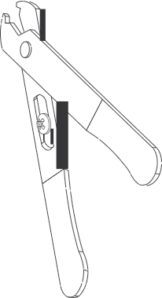

Trimpot adjustment tool

No. 2 Phillips screwdriver

Wire

Strippers

You will need to supply the following materials:

• Shielded audio cable for connecting the CM Series to the cinema processor and power amplifier outputs.

• Four 10-32 x 1/2" screws to mount the CM Series in the audio equipment rack.

FEATURES

**???**

XTM-300 Series Front Panel

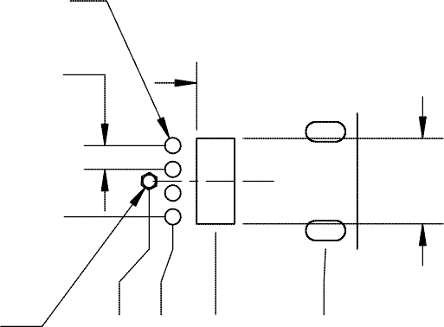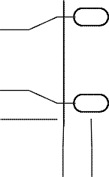

CM Series INSTRUCTION MANUAL

Ultra

Stereo Labs, Inc.

- 5 -

1. Channel select buttons - pressing a Channel Select Button causes the corresponding LED to illuminate and the signal from that channel to be monitored. Any combination of eight channels can be selected.

2. Internal Digital or Analog Crossover Access Cover.

3. Crossover Bypass Switch - Switching this will cause the internal crossover to be bypassed or engaged and the condition will be indicated by its appropriate LED.

4. Volume Control - controls the volume of the internal speaker. The volume control has no effect on the VU Bargraph display.

5. Processor/Amplifier Selector Switch - selects either the inputs from the cinema processor or power amplifiers for monitoring.

6. VU Bargraph - displays the level of the selected channels. The VU Bargraph may be calibrated by the rear panel trim adjustment. The VU Bargraph operates independently of the volume control (4).

7. Test Jack - permits monitoring of the audio output of the CM-680. Inserting a mono or stereo 1/4” phone plug here disables the internal speaker and routes the audio output to the Test Jack. Do not connect any device here with less than 8 Ohms impedance.

8. Internal Speaker

9. Power Switch

XTM-300 Series Rear Panel

1. Main AC connector with fuse.

2. Amplifier outputs - connect to the power amplifier speaker outputs corresponding to Ls, Rs, Bsl, Bsr and Sw channels.

CM Series INSTRUCTION MANUAL

Ultra

Stereo Labs, Inc.

- 6 -

3. Amplifier outputs - connect to the power amplifier speaker outputs corresponding to Lh, Ll, Ch, Cl and Rh, Rl.

4. Amplifier level - this trimpot adjusts the level of the input lines coming from the Power Amplifiers.

5. HD-15 connector - connect to Ls/Rs amplifier.

6. HD-15 connector - connect to Bsl/Bsr amplifier.

7. Processor level - this trimpot adjusts the level of the input lines coming from the processor.

8. Crossover outputs - connect to the power amplifier inputs corresponding to Ls, Rs, Bsl and Bsr.

9. HD-15 connector - connect to Rl/Rh amplifier.

10. HD-15 connector - connect to Sw amplifier.

11. Crossover outputs - connect to the power amplifier inputs corresponding to Rl, Rh and Sw.

12. HD-15 connector - connect to Ll/Lh amplifier.

13. HD-15 connector - connect to Cl/Ch amplifier.

14. Crossover outputs - connect to the power amplifier inputs corresponding to Ll/Lh and Cl/Ch amplifier.

15. Optional input - connect these to the EX outputs of the processor

16. Bargraph level - this trimpot adjusts the sensitivity of the front panel VU Bargraph.

17. Main input - connect this to the main outputs of the processor.

18. AC Emergency power input - 12-16VAC, 0.5A

19. Channel configuration DIP switches. (See Page 11)

CM Series INSTRUCTION MANUAL Ultra Stereo Labs, Inc.

Installation

Mount the XTM-300 Series

The ideal place for the XTM-300 Series Monitor is in the sound rack or projector console between the stereo processor and power amplifiers. DB25 connectors are available on the back plane to make installation quick and easy. Alternatively, terminal blocks allow the use of stripped and tinned wire. They are pluggable for easy service and trouble shooting.

XTM-300 Hookup

1. Power: Connect the unit to the AC power outlet using the standard IEC cable provided. Any power source from 100-250VAC, 50-60 Hz will be sufficient.

2. **???**

- 7 -

**???**

DB-25

Connector Pinout

|  |  |  |
| --- | --- | --- |
| Pin # | Function | Function |
| 1  2  3  4  5  6  7  8  9  10  11  12  13  14  15  16  17  18  19  20  21  22  23  24  25 | GND L + N/C GND C + N/C GND R + GND LS - RS - SW - GND L - N/C N/C C - N/C N/C R - N/C GND LS + RS +  SW + | N/C N/C Bsl - N/C Ch + Bsr - GND Rh + N/C Ls - Rs - Lh - N/C N/C N/C Bsl + Ch - N/C Bsr + Rh - N/C N/C Ls + Rs + Lh + |

Main Processor Outputs

Optional Processor Outputs

XTM-300A Version

**???**

Crossover Bypass Setup

This unit can be equipped with either the XTD-680D, a fully digital biamp/triamp crossover card, the XTA-680EA, an analog crossover card or the XTB-680B, a bypass card when no crossover functions are desired with the monitor. The XTD-680D and the XTA-680B are discussed in detail in their own instruction manuals.

1. Bypass Card XTB-680B: When using external crossovers, the CM Series must be equipped with a bypass card in the crossover slot.

For external crossovers or crossovers built into amplifiers: Turn biamp switch “ON”, triamp “OFF”.

Feed the channel “A” output of the

Ll/Lh, Cl/Ch, and Rl/Rh HD15 connectors to the appropriate amps.

OR

Feed the Ll, Cl and Rl terminals on the Phoenix connectors to the appropriate amps.



BIAMP ON TRIAMP

OFF



To USE CP-650 internal crossover with CM Series Monitors. For biamp operation, turn biamp

switch to “ON”and triamp switch “OFF”.

XTM-300D Version

**???**

Specifications

**???**

Construction

**???** The CM Series Monitor is constructed of steel to minimize hum pickup and noise radiation. The overall size of the unit is 3.5" x 19" x 9.625". The CM Series is designed to mount in a standard rack frame or cabinet.

CM-680

**???** Weight: 10 lbs. 2 oz. 4.63kg)

Shipping weight: 16 lbs. (7.26kg)

Shipping Size: 22” x 22” x 6” (558.8 x 558.8 x 152.4 mm)